**Activity 1.**

1. **Purpose of Various Communication Types:** Organizations use different communication forms like written, oral, and non-verbal to ensure efficient information flow. For example, written communication, such as emails or reports, provides a documented trail and is formal. In contrast, oral communication, like meetings or presentations, allows immediate interaction and clarification.
2. **Oral Communication Techniques for Live Audience:** Techniques such as active listening, engaging body language, clear articulation, and appropriate modulation enhance live presentations. Effective presentation skills, visual aids, and storytelling can captivate and elucidate the audience.
3. **Element for Mutual Understanding:** Feedback is crucial for mutual understanding according to communication theory. It ensures the message sent is received and understood as intended, reducing misinterpretations.
4. **Strict Procedures in Meetings:** Procedures ensure order, clarity, participation, and decision-making. They prevent chaos, keep discussions focused, and ensure equal participation.
5. **Use of Effective Data Gathering for Reports:** Data gathering techniques ensure reliable, accurate, and comprehensive information. They form the basis for well-informed reports, allowing informed decisions and strategic planning.
6. **Identifying Target Audience:** Techniques like audience analysis help identify demographics, needs, and preferences of the audience. This ensures tailoring the message to suit their understanding and interests.
7. **Two Oral and Written Techniques:** Oral - Active Listening and Storytelling; Written - Audience Analysis and Conciseness. Active listening enhances understanding, while storytelling engages audiences. Audience analysis ensures tailored messages, and conciseness aids clarity.
8. **Implications of Not Adapting to Audience Requirements:** Poor communication can lead to misunderstandings, lack of engagement, and decreased productivity, affecting relationships and organizational goals.
9. **Relationship Between Oral and Written Communication:** Both complement each other; written communication supports documentation and clarity, while oral communication allows immediate interaction and clarification. Leaders need to excel in both for effective management.
10. **Importance of Regulations in Communication:** Regulations ensure adherence to legal requirements, ethical standards, and company policies, fostering trust, credibility, and avoiding legal consequences.
11. **Impact of Emotional Intelligence:** Emotional intelligence influences workplace relationships and productivity. For instance, managing emotions positively fosters teamwork, conflict resolution, and a positive work environment.
12. **Intra and Inter-Personal Relations:** Strong relationships boost collaboration, trust, and morale. Intra-personal relations help self-awareness, while inter-personal relations aid teamwork and communication.
13. **Impact of Negative Emotional Intelligence:** Poor emotional intelligence can lead to conflicts, reduced morale, and hamper productivity, affecting the work environment negatively.

**Activity 2.1**

*From: 08 January 2024*

*From: 19 January 2024*

*Subject: Assessment of Communication in the Department*

**Executive Summary:**

This report provides an overview of communication within the department over a two-week observation period. The analysis covers communication methods, their relation to communication theory, employee engagement, potential misunderstandings, and conflicts arising from current communication practices. Recommendations for improvement are also presented.

**1. Communication Methods:**

During the observation period, several communication methods were employed in the department, including:

* **Email:** Used for formal communication and documentation of important information.
* **MS Teams:** Utilized for real-time collaboration, team discussions, and quick updates.
* **Direct Phone Calls:** Employed for urgent matters or detailed discussions requiring immediate clarification.

**2. Application of Communication Theory:**

The communication methods align with various communication theories, primarily focusing on:

* **Shannon-Weaver Model:** The use of email and direct phone calls reflects a sender-receiver model, emphasizing the transmission of information.
* **Kincaid’s Convergence Model:** MS Teams fosters mutual understanding and feedback, contributing to effective communication.

**3. Recommendations for Improvement:**

To enhance communication in line with communication theories:

* **Encourage Transparent Collaboration:** Emphasize the importance of transparent collaboration, ensuring that information is shared openly within teams.
* **Establish Clear Protocols:** Develop protocols for sharing project details, such as database structures, to avoid delays and confusion.
* **Timely Responses:** Encourage prompt responses to queries, reducing the risk of misunderstandings.

**4. Employee Engagement:**

Employee engagement appears satisfactory, with active participation in team discussions and collaborative efforts observed. However, there are areas where engagement could be further improved, especially regarding information sharing between team members.

**5. Misunderstandings:**

Due to a lack of information on database structures in certain projects, there were instances where developers faced confusion and potential misunderstandings. These gaps in information flow impacted project timelines.

**6. Conflict Resolution:**

While no major conflicts were observed, the delays caused by the lack of information on certain projects led to minor tensions. Improving transparency and information sharing could prevent such conflicts.

**7. Conclusion:**

The department exhibits effective communication practices, but there is room for improvement, especially in terms of transparent collaboration and timely information sharing.

**8. Recommendations:**

Based on the findings, the following recommendations are suggested:

* **Implement Database Information Sharing Protocols:** Clearly define how information about database structures should be shared between backend and frontend developers.
* **Regular Training on Effective Communication:** Conduct regular training sessions to enhance communication skills and emphasize the importance of transparent collaboration.
* **Establish Feedback Mechanisms:** Implement systems for collecting feedback on communication processes to continuously improve practices.

Thank you for your attention to this matter. If you have any questions or require further clarification, please feel free to contact me.

Sincerely*,*

Philasande Bhani.  
Software Developer Intern.  
PhilasandeB@cappayments.co.za

**Activity 2.2**

1. **The completed presentation.**



1. **Notes on the discussion points.**

**Main Points:**

1. Communication Methods Overview.
2. Application of Communication Theory.
3. Recommendations for Improvement.
4. Employee Engagement and Impact on Performance.
5. Misunderstandings and Conflict Resolution.
6. **Video recording of the presentation.**

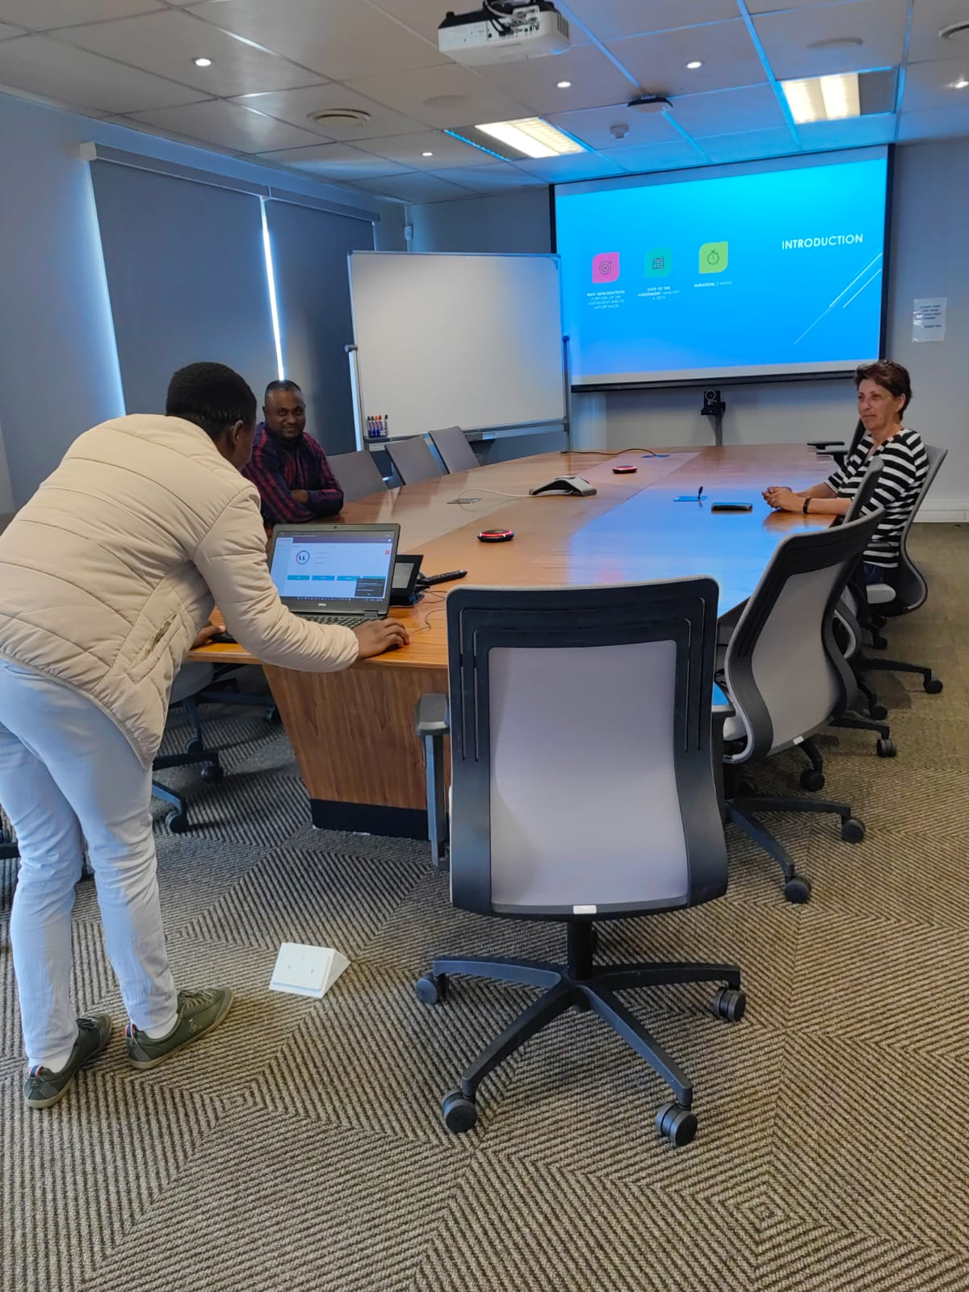

1. **Completed evaluation form – in logbook.**

**Activity 2.3**

1. **Agenda for the Meeting:**



1. **Email notifications of the notice of meeting and invitations sent.**

1. **Video recording of you conducting the meeting.**

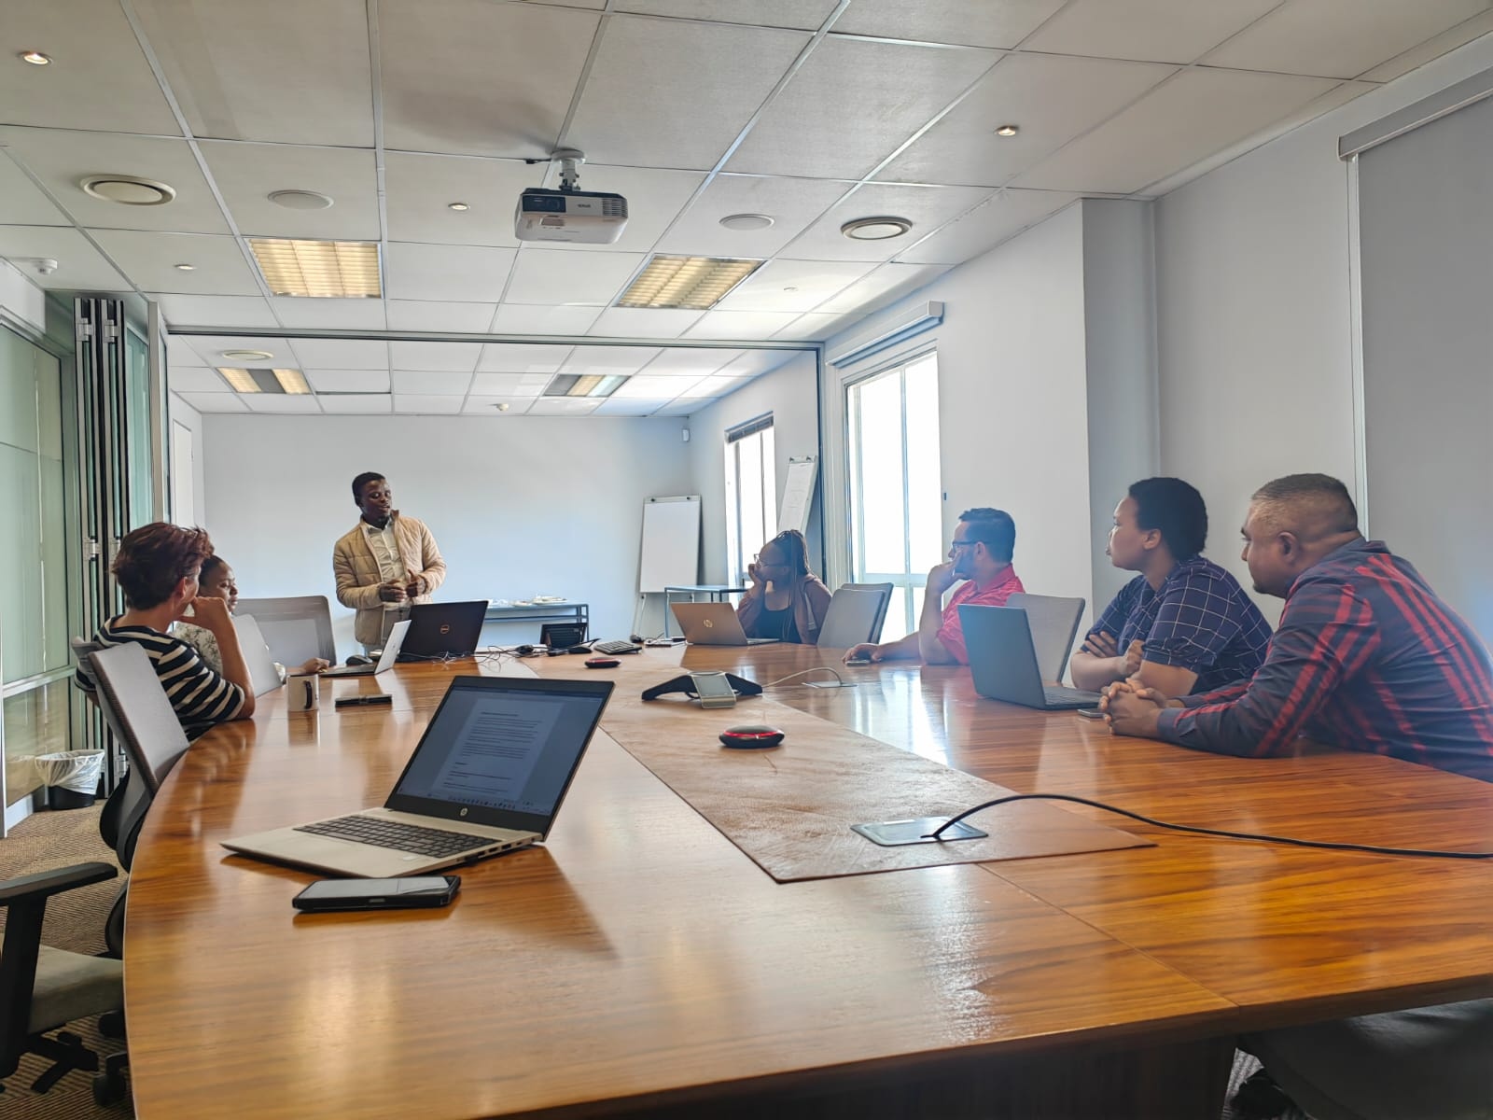

1. **The completed minutes of the meeting.**



1. **Email confirmation of the distribution of the finalised minutes.**

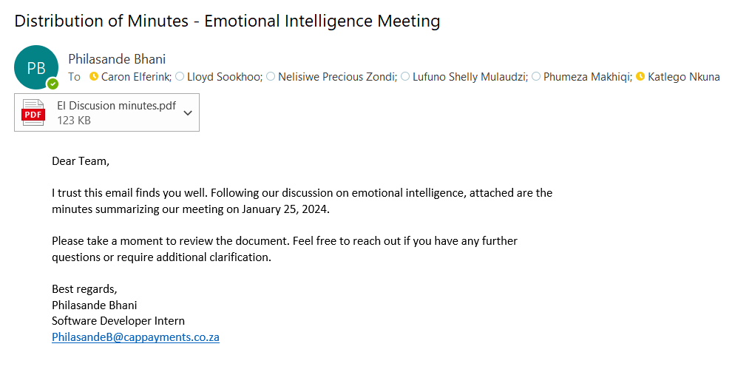

1. **A reflection report in which you reflect on your own performance during the meeting, i.e., what did you handle well, what could you improve on, what needs to change, etc.**



**Activity 2.4**

**(a). Discuss using a suitable written communication method, your approach, strategies, and techniques used to Identify, create, and explore the network opportunity. Explain the opportunities identified and why these were applicable to your network.**

**Identifying and Exploring Network Opportunities: A Brief Overview**

**Approach:**

1. **Objective Clarity:** Clearly defined networking goals.
2. **Research:** Explored relevant industry events, associations, and online platforms.
3. **Targeted Outreach:** Personalized communication to specific contacts.

**Strategies and Techniques:**

1. **LinkedIn:** Leveraged LinkedIn for professional networking.
2. **Events and Conferences:** Attended industry gatherings for networking.
3. **Professional Associations:** Joined groups forstructured networking.
4. **Value Offering:** Shared resources and made introductions to provide value.

**Opportunities Identified:**

1. **Collaborative Projects:** Identified opportunities for partnerships.
2. **Mentorship:** Connected with mentors for guidance.
3. **Career Advancement:** Discovered job openings and referrals.

**Applicability to Network:** Aligned with career goals, industry focus, and professional development needs, facilitating growth and collaboration within the network.

**(b). Email to the organisers as confirmation of attending the function.**

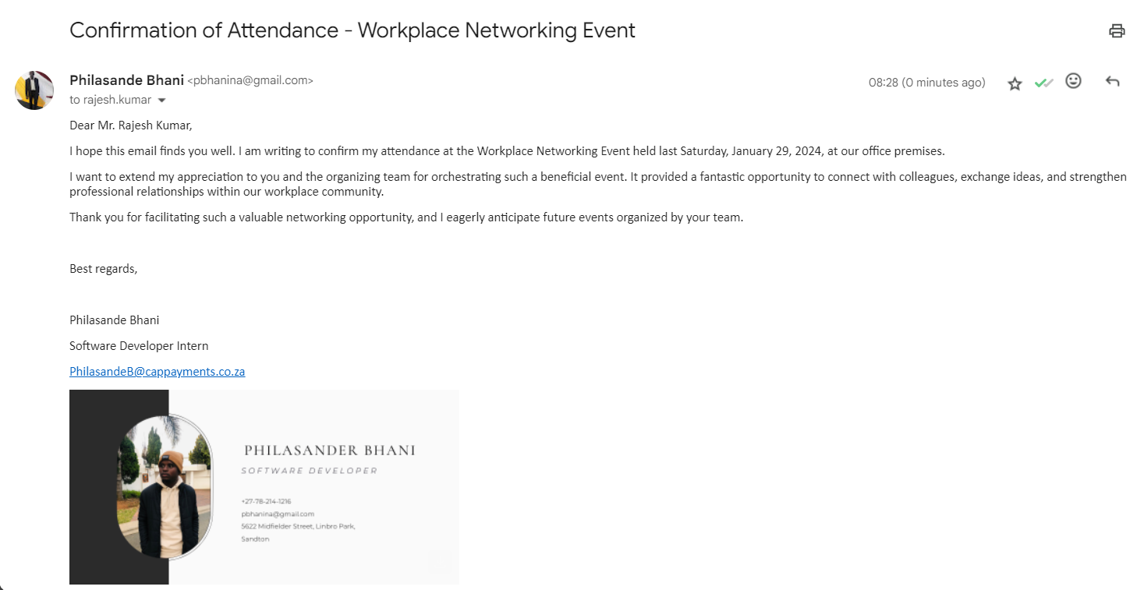

**(c). Feedback Report explaining your approach and method of personal interaction at the function. Make special reference to the techniques used during the session to establish the connection.**

**Feedback Report: Personal Interaction at Workplace Networking Event**

**Approach and Method:**

During the Workplace Networking Event, I focused on active engagement and genuine interest to establish connections with colleagues.

**Techniques Used:**

**1. Open Body Language:** Maintained a welcoming demeanour through smiling and eye contact.

**2. Active Listening:** Showed genuine interest by actively listening to colleagues' perspectives.

**3. Asking Open-Ended Questions:** Initiated dialogue by asking about colleagues' experiences and interests.

**4. Finding Common Ground:** Established connections by identifying shared interests or experiences.

**5. Follow-Up:** Continued engagement post-event through email or LinkedIn to nurture relationships.

**Conclusion:**

Through these techniques, I successfully fostered connections and contributed to a stronger workplace community. I remain committed to further developing these skills for future networking opportunities.

Best regards,

Philasande Bhani

Software Developer Intern

PhilasandeB@cappayments.co.za

**Activity 2.5**

**(a) Planned and Prepared Notes for the Discussion:**

**Discussion Agenda - January 30, 2024**

1. **Introduction and Purpose**:
   * Brief introduction of the discussion's purpose: to establish constructive relationships with the manager.
2. **Presenting Current Activities and Progress**:
   * Overview of daily activities and progress made.
   * Highlight any challenges faced.
3. **Discussing Communication Methods and Improvement Strategies**:
   * Propose strategies for enhancing communication methods.
   * Seek input from managers on effective communication practices.
4. **Soliciting Input on Promoting Constructive Relationships**:
   * Encourage managers to share thoughts and suggestions on fostering positive relationships.
5. **Addressing Quality of Work Issues**:
   * Openly discuss any identified quality of work issues and propose solutions.
6. **Conclusion and Next Steps**:
   * Summarize key points discussed and outline next steps.

**(b). Video of Leading the Discussion:**

**(c). Detailed Feedback Report on Discussions:**

**Discussion Feedback Report - January 30, 2024**

* The discussion commenced with a clear introduction of the purpose, setting a positive tone for the session.
* Philasande effectively presented current activities and progress, demonstrating a thorough understanding of ongoing tasks.
* Communication methods and improvement strategies were discussed collaboratively, with valuable input from all participants.
* Managers provided insightful input on promoting constructive relationships, emphasizing the importance of mutual respect and communication.
* Identified quality of work issues were addressed constructively, with actionable steps proposed for improvement.

**(d). Plan of Action Developed to Establish Constructive Relationships:**

**Action Plan - Establishing Constructive Relationships**

1. Implement regular progress updates to keep the manager informed.
2. Schedule bi-weekly feedback sessions to address any concerns or issues promptly.
3. Utilize collaboration tools for effective communication and task management.
4. Organize team-building activities to foster a positive work environment.
5. Follow up on action items discussed during the meeting.

**(e). Complete Observation of Your Performance During the Discussion from Your Manager: To be completed in Logbook**

**Activity 2.6**

**a. Team Briefing confirmation of information discussed, this can be in the form of an email to the team.**

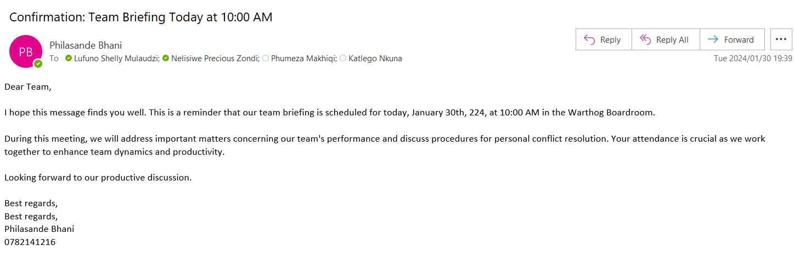

**b. Written feedback to the team and or each member, providing written feedback on performance as discussed in the Team briefing, as well as the recipient of their reply to the feedback received. This can be in the form of an email conversation.**

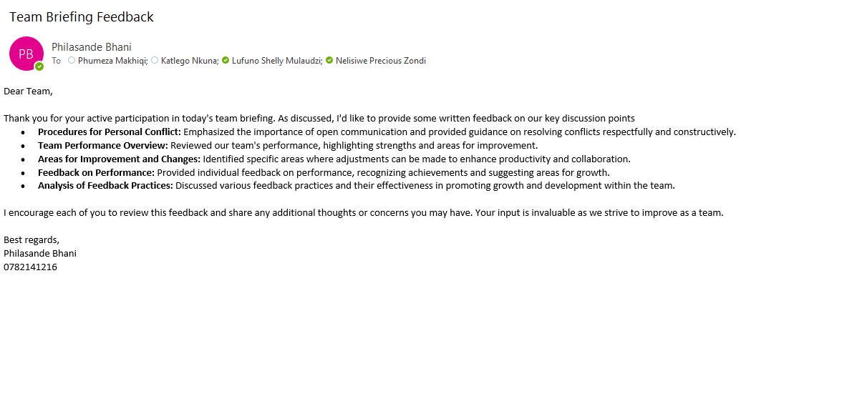

**Nelisiwe’s Reply**

**c. a and b can be combined in one email, if comprehensively and clearly stated in writing.**

**A and B**

**d. Request your team to provide you with feedback on your performance as a leader, how well you interact and engage, what you could do differently, is there something that you do or say that causes ill feeling, etc. This can be in an email or develop an evaluation form for them to complete and provide the completed evaluations.**

**e. In a suitable professionally formatted document, explain how the feedback you provided to your team, that they provided you with, compared to the analyzed practices and what would you do differently?**



**Activity 2.7**

**Identify conflict situations in your immediate workplace, this may be conflict between other parties or involving yourself, then answer the following questions in a suitable document format:**

**a. Conflict Situation Explanation:**

* **Situation:** There are conflicts within the team regarding the process of saving assets to the database and assigning them to employees simultaneously. One group argues that assets should be saved and assigned at the same time, while the other group suggests that assets should be saved first and then assigned later due to the need for an asset number generated during the saving process.

**b. Conflict Resolution Action:**

* **Step 1: Clarify Objectives:** Arrange a team meeting to discuss the objectives of the asset saving and assignment process. Clearly outline the requirements for both saving assets to the database and assigning them to employees.
* **Step 2: Evaluate Technical Constraints:** Assess the technical feasibility of saving and assigning assets simultaneously versus sequentially. Consider factors such as data integrity, system performance, and the availability of asset numbers during the saving process.
* **Step 3: Risk Assessment:** Conduct a risk assessment to identify potential issues and challenges associated with each approach. Evaluate the impact of errors or inconsistencies on asset management and employee productivity.
* **Step 4: Collaboration and Consensus:** Foster open dialogue and collaboration among team members to explore alternative solutions that address the concerns raised by both groups. Encourage compromise and negotiation to reach a consensus on the most effective approach.
* **Step 5: Decision Implementation:** Communicate the agreed-upon decision to all stakeholders and implement the chosen approach. Monitor the implementation process closely and address any issues or challenges that arise during the transition.

**c. Impact of Emotional Intelligence:**

* **Positive Impact:** Emotional intelligence can facilitate empathy and understanding among team members, enabling them to appreciate the perspectives and concerns of both groups. It can help in managing emotions during discussions, leading to constructive dialogue and conflict resolution.
* **Negative Impact:** However, if team members lack emotional intelligence, they may struggle to regulate their emotions, leading to escalated conflicts, misunderstandings, and an inability to find common ground. Emotional intelligence deficits can hinder effective communication and prolong the resolution process.

**d. Consultative Strategy for Goal Development:**

* **Step 1: Individual Discussions:** Meet with each group individually to discuss their concerns and perspectives on the asset saving and assignment process. Encourage open dialogue and active listening to understand their viewpoints.
* **Step 2: Joint Meeting:** Organize a team meeting to facilitate a collaborative discussion on the goals and objectives of the asset management process. Encourage team members to share their goals and concerns regarding the process.
* **Step 3: Mediation and Agreement:** Act as a mediator to help team members reach a consensus on the approach to be taken regarding asset saving and assignment. Facilitate compromise and negotiation to ensure that the decision aligns with the project goals and objectives.
* **Step 4: Documentation and Follow-Up:** Document the agreed-upon decision regarding the asset saving and assignment process and the rationale behind it. Establish a timeline for regular check-ins to monitor progress and address any further concerns that may arise.

**Activity 2.8**

**Workplace Reports Overview**

**1. Project Progress Report**

**a. Title:** Project Progress Report  
**b. Recipients:** Team Leads, Project Managers  
**c. Frequency:** Bi-weekly  
**d. Information Source:** Team Members, Task Management Software  
**e. Business Reason:** To track the progress of ongoing projects, identify bottlenecks, and ensure alignment with project timelines.

**Explanation:** The Project Progress Report provides a comprehensive overview of the status of ongoing projects. It establishes connections by fostering collaboration among team leads and project managers. Accurate reporting is crucial to meet project deadlines and identify areas for improvement. Policies and procedures ensure consistency in reporting formats and timely submissions.

**2. Financial Performance Summary**

**a. Title:** Financial Performance Summary  
**b. Recipients:** CFO, Department Heads  
**c. Frequency:** Monthly  
**d. Information Source:** Accounting Software, Financial Statements  
**e. Business Reason:** To evaluate the financial health of the organization, allocate resources efficiently, and make informed strategic decisions.

**Explanation:** This report serves as a snapshot of the company's financial standing. Recipients, including the CFO and department heads, rely on accurate financial data for budgeting and decision-making. Inaccurate reporting may lead to misguided financial strategies. Policies ensure compliance with accounting standards and transparent financial reporting.

**3. Employee Productivity Metrics**

**a. Title:** Employee Productivity Metrics  
**b. Recipients:** HR Manager, Department Supervisors  
**c. Frequency:** Weekly  
**d. Information Source:** Time Tracking Software, Task Management Tools  
**e. Business Reason:** To monitor individual and team productivity, identify training needs, and allocate resources effectively.

**Explanation:** This report tracks employee productivity, facilitating performance evaluations. It establishes connections by fostering transparency and open communication between employees and supervisors. Accurate reporting is vital for fair performance assessments. Policies ensure confidentiality and ethical use of productivity data.

**4. Customer Satisfaction Survey Report**

**a. Title:** Customer Satisfaction Survey Report  
**b. Recipients:** Customer Service Team, Marketing Department  
**c. Frequency:** Quarterly  
**d. Information Source:** Customer Feedback Surveys  
**e. Business Reason:** To measure customer satisfaction, identify areas for improvement, and enhance overall customer experience.

**Explanation:** This report compiles customer feedback, fostering connections between customer service teams and marketing departments. Accurate reporting is critical to address customer concerns promptly. Policies ensure the ethical collection of customer feedback and protection of customer privacy.

**5. IT Security Incident Report**

**a. Title:** IT Security Incident Report  
**b. Recipients:** IT Security Team, Executive Management  
**c. Frequency:** As Needed (Upon Incidents)  
**d. Information Source:** Incident Logs, Security Software Alerts  
**e. Business Reason:** To report and analyses security incidents, mitigate risks, and protect sensitive information.

**Explanation:** This report details security incidents, connecting IT security teams and executive management. Accurate reporting is crucial to identify vulnerabilities and prevent data breaches. Policies ensure the prompt reporting of incidents, adherence to security protocols, and continuous improvement of cybersecurity measures.

**Question 3**

**Activity 3.1**

1. **General Reactions and Responses:** a. **Relation to 5 Principles of Emotional Intelligence:**
   * Self-awareness: Recognizing how my reactions and responses impact others.
   * Self-regulation: Learning to control impulsive reactions and manage emotions effectively.
   * Motivation: Striving for positive outcomes and growth, even in challenging situations.
   * Empathy: Understanding others' perspectives and emotions.
   * Social skills: Communicating effectively and resolving conflicts constructively.

b. **Current Emotional Intelligence Rating:**

* + I believe I demonstrate a strong level of emotional intelligence, but there is always room for improvement.

c. **Changes I Would Make:**

* + Increase self-awareness by reflecting more on my actions and their impact on others.
  + Practice active listening to enhance empathy and understanding.
  + Develop strategies for managing stress and emotions more effectively.

d. **Preferred Response to Situations:**

* + Respond calmly and thoughtfully, considering the feelings and perspectives of others.
  + Seek constructive solutions rather than reacting impulsively.

e. **Strengths and Weaknesses:**

* + Strengths: Empathy, adaptability, and conflict resolution skills.
  + Weaknesses: Tendency to overthink situations and occasional difficulty in managing stress.

f. **Impact on People Around Me:**

* + Strengths positively affect teamwork, communication, and morale.
  + Weaknesses may lead to occasional misunderstandings or heightened tension.

g. **Learning from Team Feedback:**

* + Received valuable insights into areas for improvement, particularly in communication and stress management.
  + Plan to implement changes by actively seeking feedback and addressing concerns proactively.

h. **Emotional Habits to Change:**

* + Proactively address stress triggers and implement relaxation techniques.
  + Practice mindfulness and self-reflection to enhance self-awareness.

i. **Emotional Intelligence Techniques to Apply:**

* + Active listening
  + Mindfulness meditation
  + Conflict resolution strategies
  + Stress management techniques

**Professional Development Plan**

1. **Development Area:** Stress Management
   * **Why Develop This Area:** To enhance overall well-being and effectiveness in handling challenging situations.
   * **Actions to Take:** Attend stress management workshops, practice relaxation techniques daily, and seek mentorship from experienced professionals.
   * **Who Can Help:** Human resources department, stress management experts, and supportive colleagues.
   * **Resources Needed:** Access to stress management resources, workshops, and guidance from mentors.
   * **Deadline for Completion:** 6 months